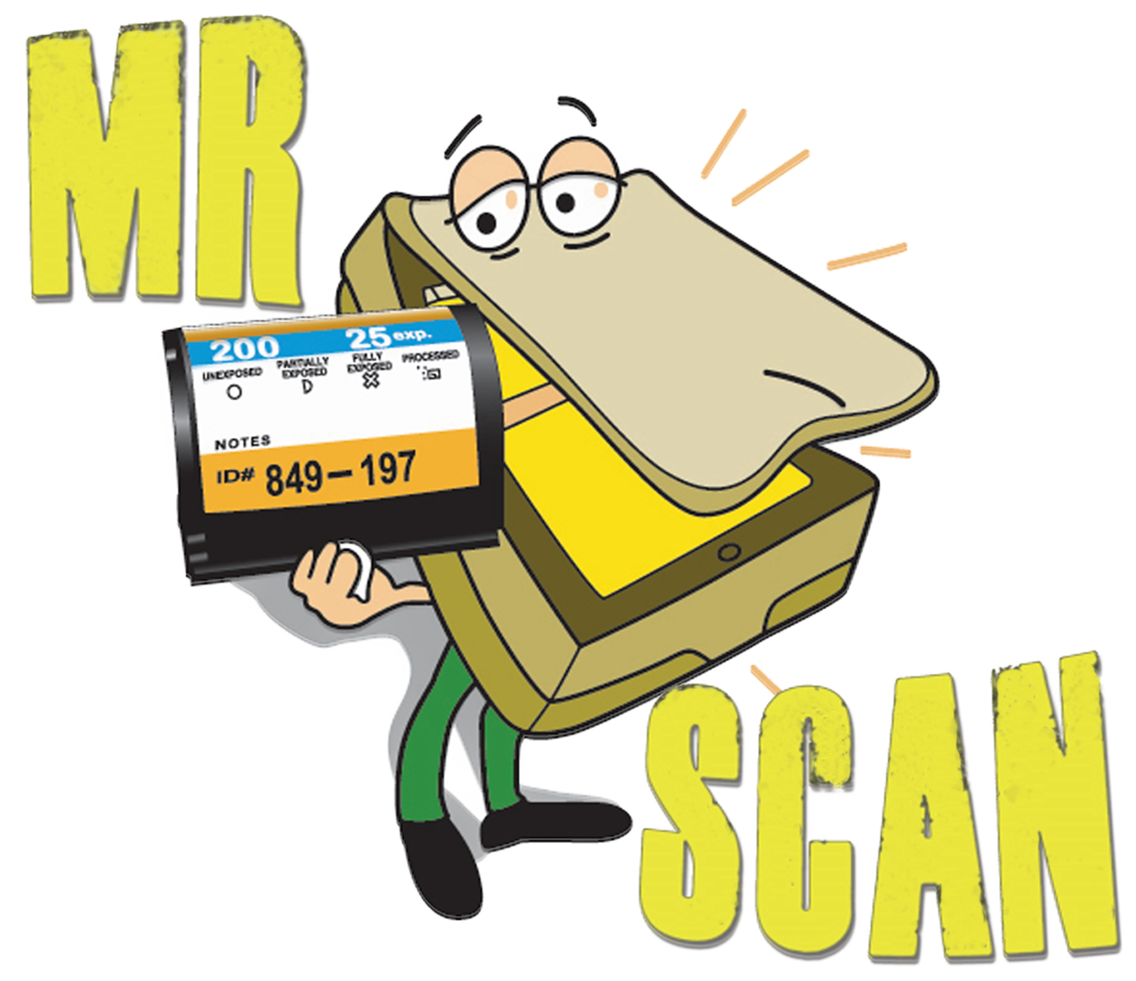
MR SCAN LTD.
“THE OAST HOUSE”
5 MEAD LANE
FARNHAM
SURREY
GU9 7DY
01252 416202
Please fill in this form and send with your films:
Please note: You do not need to fill in this form if you have already paid for an order online, all you need to do is print your order confirmation Email which you should have received (check junk emails)
Name
Email Address
Return Delivery Address

Phone Number
Please make a list below of the types of films you are sending for scanning including quantity if know:
Simple Scanning Service - Roughly count your images/films when using our simple scanning service so you know an estimate cost – Please use our website film guide to identify your film, if in doubt just send us a photo or ask us.
Digital image preference |  |  | JPG (Standard) |  |  | TIFF (Professional)
How do you want your digital data? | CD/DVD   |  | Download   |  |  | USB Stick   | SD Card   |  | Hard Drive  
Payment | Online Payment already made   |  |  |  |  | To be Invoiced via Email  
Return Shipping | DOWNLOAD SERVICE ONLY  Originals not returned   |  |  |  | Just Media Originals not returned   | Personal Collection   |  | Standard Post/Courier   |  |  | Tracked Post/Courier  
How did you first hear of Mr Scan?
Customer Signature:  Signed to agree with Mr Scan terms and conditions as per our website |  |  |  | Date:
Please make any additional notes or instructions you wish us to know on the reverse of this order from.
If you are planning to drop off your package in person, please email or call us to make an appointment.
Visiting Mr Scan is via appointment only

Please fill in and attach this address label to your package
If your package does not contain this label it may cause delays in your order being processed.

Don’t forget to pay for your postage and fill in your return address.
If you have not made an online order don’t worry, will not have an order number; just leave this section blank.
Please put your return address on the back of the package.

::::::::::::::::::::::::::::::::::::::::::::::::::::::::::: Cut Here:::::::::::::::::::::::::::::::::::::::::::::::::::

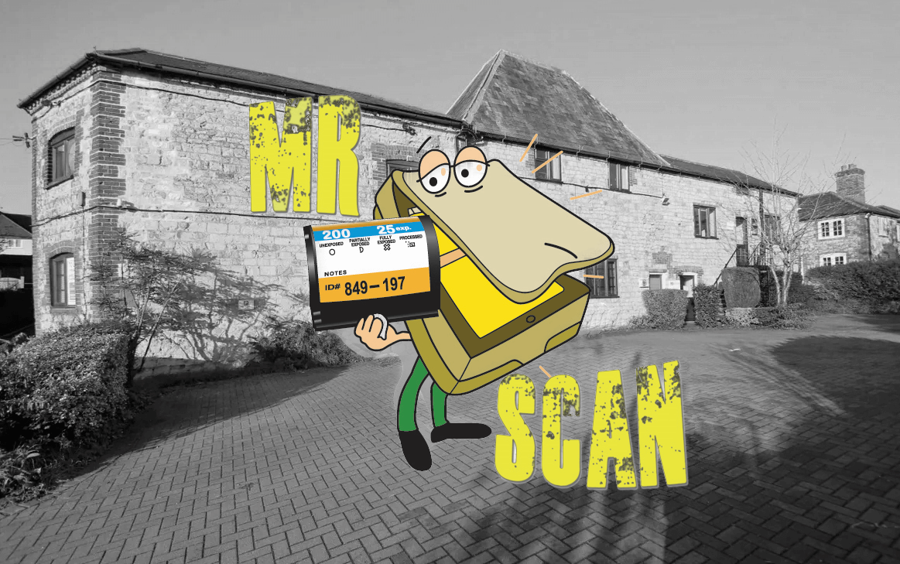 | Mr Scan Ltd.  “THE OAST HOUSE”  5 MEAD LANE  FARNHAM  SURREY  GU9 7DY  United Kingdom  What3word:  Jazz.hatter.mouths
COURIERS: PLEASE USE CAR PARK ENTRANCE
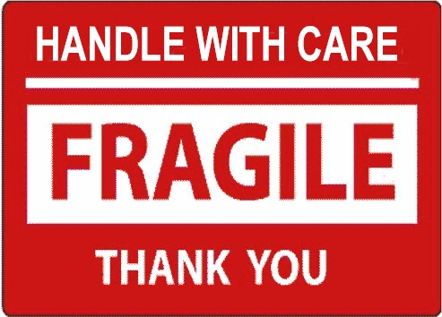
Important information
Order number: | RC
Customer Name:

